STANDARD OPERATING PROCEDURE

Replace the gripper servo (motor 6) on the SO-101 follower arm
Filled-in example based on the public TwinWorks procedure “Replacing servomotor 6” for the open-source SO-101 arm (twinworks.com/community/so-101.html). Illustrative: check it against the official LeRobot documentation before use.
Document ID | SOP-EX-101 | Revision | A
Owner | Lab technician | Approver | Lab lead
Effective date | 2026-11-04 | Next review | 2027-11-04
Department / area | Robotics lab | Applies to | SO-101 follower arm, gripper
Supersedes | None | Status | Example

1. Purpose
Replace a faulty gripper servo on the SO-101 follower arm with a new Feetech STS3215, so that the gripper opens and closes under LeRobot control again.

2. Scope
Applies to: the gripper servo (motor ID 6, labelled Servo6 in the 3D model) of the SO-101 follower arm.
Does not cover: the other five servos, the leader arm, or wiring faults outside the gripper servo cable.

3. Responsibilities
Role | Responsibility
Technician | Replaces the servo, sets its ID, recalibrates the arm and fills in the log.
Lab lead | Checks the arm works before it is used again, and keeps this procedure current.

4. Definitions and abbreviations
Term | Definition
LeRobot | Hugging Face’s open-source robotics library, used to set up and calibrate the arm.
STS3215 | Feetech serial bus servo used in the SO-101 joints.
Motor ID | Address of a servo on the bus. The gripper is ID 6.

5. Safety and PPE
Hazards: unexpected movement of the arm if it is powered; pinch points at the jaw.
Before you start: disconnect the power supply and the USB cable. Keep fingers clear of the jaw when you power the arm again.
PPE: ☐ None beyond the lab rules

6. Materials, tools and equipment
Item | Specification / part number | Qty
#1 Phillips screwdriver | — | 1
Feetech STS3215 servo | 1/345 gearing (C001), same voltage as the arm: 7.4 V or 12 V | 1
M3 × 6 mm pan-head screws | DIN EN ISO 7045, reused | 8
M2 × 6 mm screws | Servo mounting, reused | 4
Computer with LeRobot installed | huggingface.co/docs/lerobot | 1

7. Procedure
No. | Action | Key point | Reason | Image
1 | Disconnect the power supply and USB cable, then remove the four M3 × 6 mm screws on the first side of the moving jaw. | #1 Phillips screwdriver. Keep the screws: all eight are reused. | No power on the servo bus while you work. | 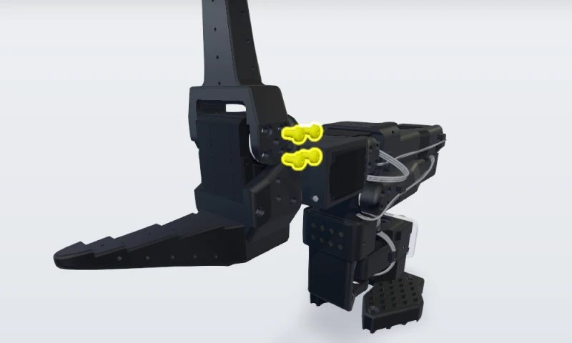
2 | Remove the four M3 × 6 mm screws on the other side of the moving jaw. | Support the jaw as the last screw comes out. | The jaw comes free with the last screw. | 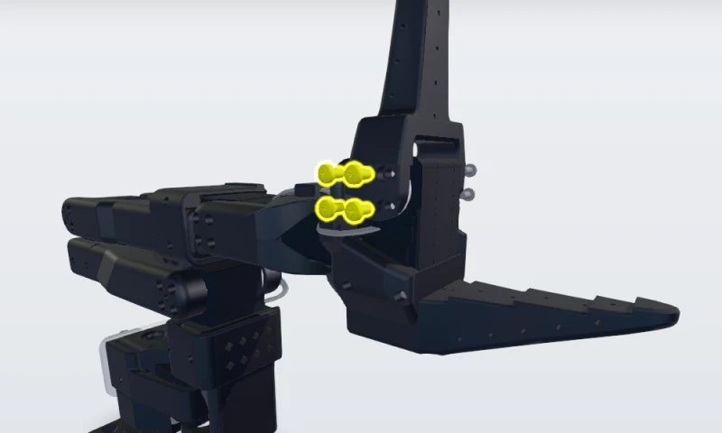
3 | Lift the moving jaw off the servo horns and set it aside with its eight screws. | Note which way the jaw faces. | It must go back the same way. | 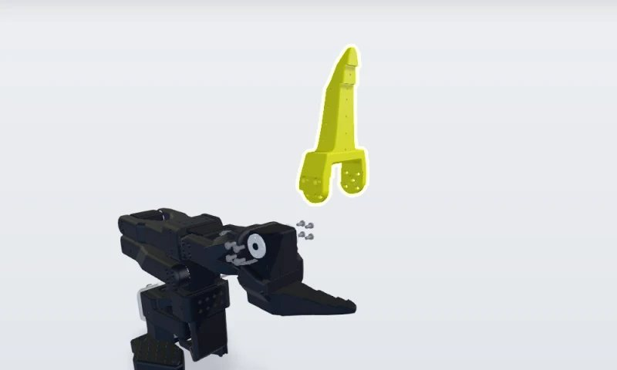
4 | Unplug the 3-pin cable from servomotor 6. | Pull the connector, not the wires. Servomotor 6 has one cable only, coming from servomotor 5. | It is the last servo in the chain. | 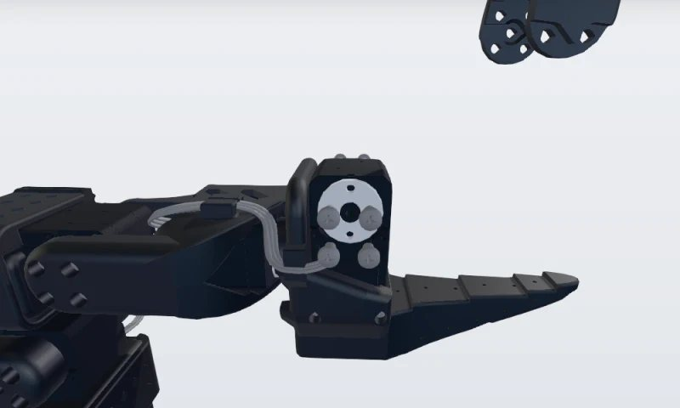
5 | Remove the four M2 × 6 mm screws that hold servomotor 6 in the lower jaw, slide the old servo out and fit the new one. | Same type: STS3215 with 1/345 gearing. Fit both horns; the top horn takes an M3 × 6 mm screw. Output shaft on the moving-jaw side. | Every joint of the follower arm uses this servo, and the jaw mounts on its horns. | 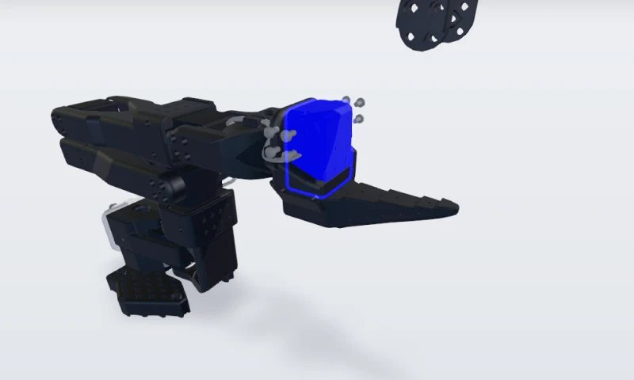
6 | Give the new servo ID 6, then plug in the cable from servomotor 5. | Connect the driver board to the new servo alone and run lerobot-setup-motors. Press Enter at the gripper prompt. | A new servo comes set to ID 1; LeRobot expects the gripper on ID 6. | 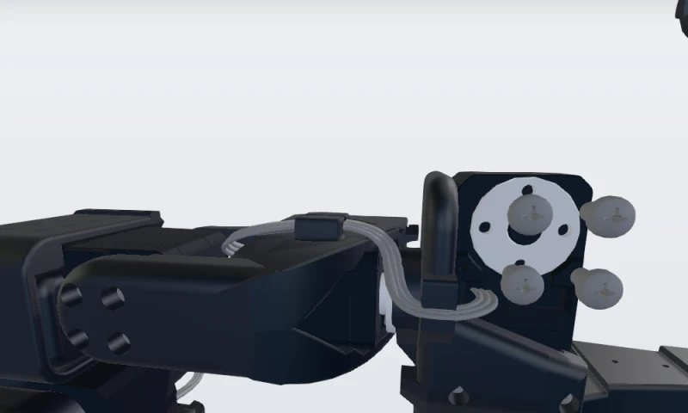
7 | Place the moving jaw back on the new servo's horns. | Facing the same way as before, screw holes lined up on both sides. | So the screws go in without force. | 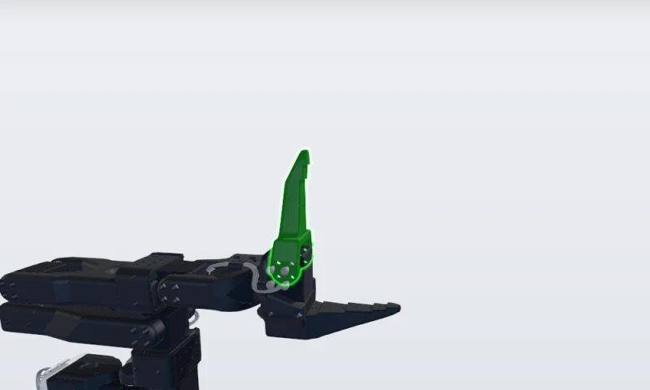
8 | Refit the four M3 × 6 mm screws on the first side. | #1 Phillips screwdriver. Leave them slightly loose. | So the second side lines up. | 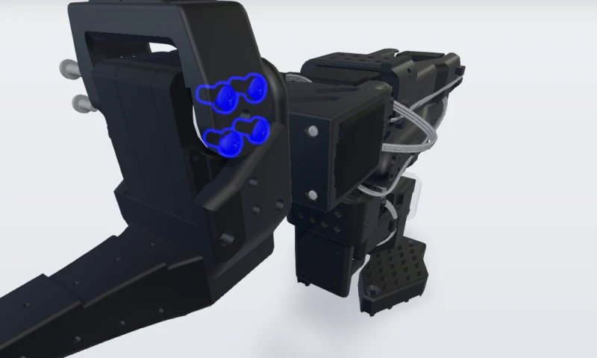
9 | Refit the other four screws, tighten all eight evenly, then recalibrate the arm. | Open and close the jaw by hand: it must move freely. Run lerobot-calibrate with the same arm name as before. | A new servo has no calibration. | 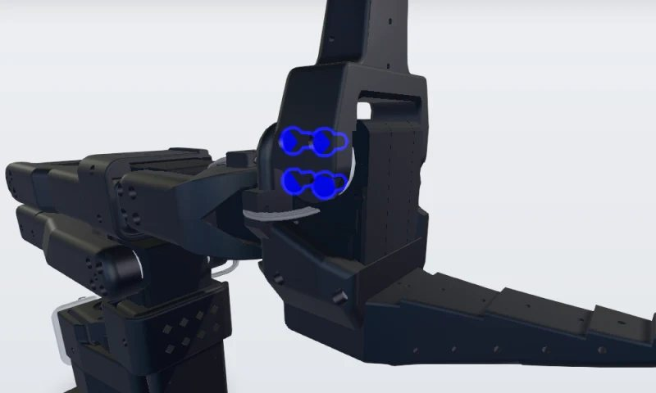

8. Quality checks
Check | Method / tool | Acceptance criterion | Record
Jaw moves freely | Open and close by hand | Full travel, no binding | Tick in the log
Gripper servo on ID 6 | lerobot-setup-motors | “'gripper' motor id set to 6” | Log entry
Arm calibrated | lerobot-calibrate | Every joint moved through its full range | Log entry

9. Records
Record | Where it is kept | Retention
Maintenance log entry: date, arm name, servo replaced, done by | Lab logbook | Life of the arm

10. References
• TwinWorks public procedure “Replacing servomotor 6”: twinworks.com/community/so-101.html
• LeRobot SO-101 guide: huggingface.co/docs/lerobot/so101
• SO-ARM100 design files and parts list: github.com/TheRobotStudio/SO-ARM100

11. Revision history
Rev. | Date | Description of the change | Author | Approved by
A | 2026-11-04 | First issue (example) | TwinWorks | —

Approval
 | Prepared by | Reviewed by | Approved by
Name
Signature
Date

