TRAINING MANUAL

SO-101 follower arm: replacing the gripper servo
Lab technicians · 45 minutes · On the bench, with a trainer
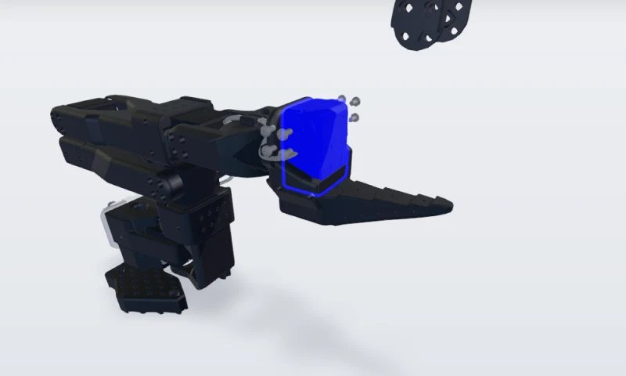

Filled-in example built from the public TwinWorks procedure “Replacing servomotor 6” for the open-source SO-101 arm (twinworks.com/community/so-101.html); images from its 3D steps. Illustrative: check it against the LeRobot documentation before use.

Document no. | TM-EX-101 | Revision | A
Course owner | Lab lead | Effective date | 2026-11-04
Related procedure | WI-EX-101 | Next review | 2027-11-04

How to use this manual
• Work through the modules in order. Each lesson has an objective, the steps with pictures, the key points and a short check.
• Do the practical exercise with a trainer, on the real machine, with this manual open.
• The trainer signs the record when you can do the task alone, to the standard.

Learning objectives
No. | Objective | Assessed by
1 | Make the arm safe and remove the moving jaw. | Observed in the exercise
2 | Replace servomotor 6 with a new STS3215 of the same type. | Observed in the exercise
3 | Give the new servo ID 6 and recalibrate the arm. | Script output and a working gripper

Prerequisites and safety
Before this course: lab induction; LeRobot installed on the bench computer.
⚠ WARNING | A powered arm can move without warning and pinch fingers at the jaw.  Disconnect the power supply and the USB cable before you start, and keep fingers clear when you power it again.

PPE: ☐ None beyond the lab rules

Equipment for the course
• SO-101 follower arm and its driver board
• New Feetech STS3215 servo, 1/345 gearing
• #1 Phillips screwdriver; computer with LeRobot

MODULE 1

Remove the old servo
Objective: Make the arm safe, remove the moving jaw and replace servomotor 6.
Step | What to do | Key point | Picture
1 | Remove the first set of jaw screws  Disconnect the arm’s power supply and USB cable first. Then remove the four M3 × 6 mm screws that hold the moving jaw to the servo horn on this side. | #1 Phillips screwdriver. Keep the screws for reassembly. | 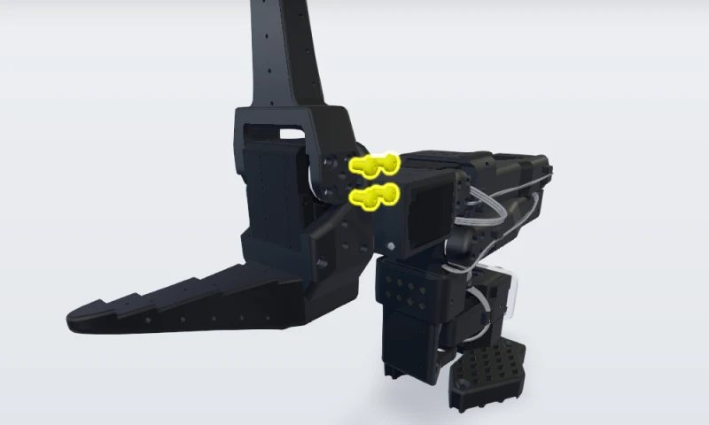
2 | Remove the second set of jaw screws  Remove the four M3 × 6 mm screws on the other side of the moving jaw. | Support the jaw as the last screw comes out. | 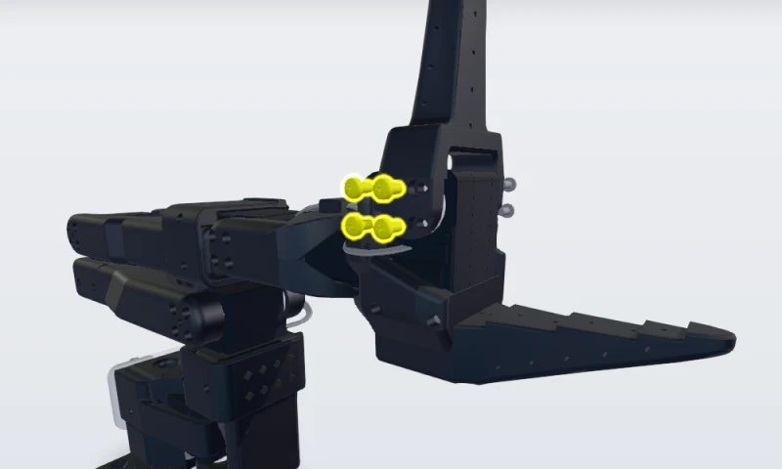
3 | Remove the moving jaw  Lift the moving jaw off the servo horns and set it aside with its eight screws. | Note which way it faces, to refit it the same way. | 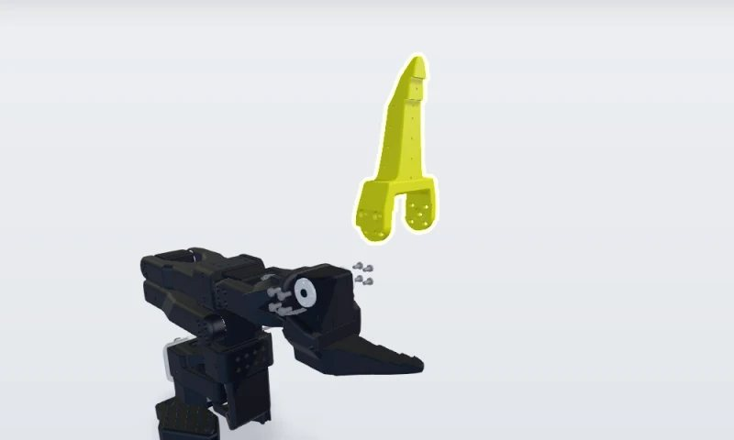
4 | Unplug servomotor 6  Unplug the 3-pin cable from servomotor 6. It is the last servo in the chain, so it has only one cable, coming from servomotor 5. | Pull the connector, not the wires. | 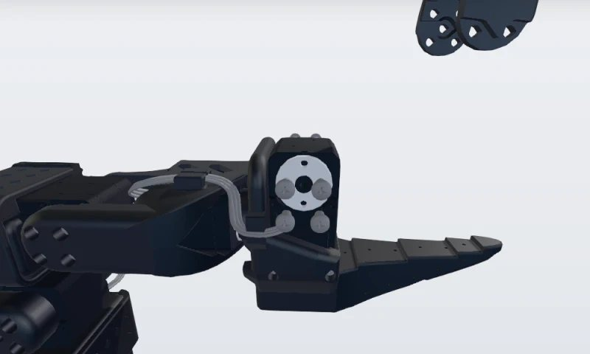
5 | Replace the servomotor  Remove the four M2 × 6 mm screws (two on each side) that hold servomotor 6 in the lower jaw and slide the old servo out. Fit both horns on the new STS3215 (1/345 gearing), securing the top horn with an M3 × 6 mm screw. Slide it in and refit the four M2 × 6 mm screws. | Output shaft on the moving-jaw side. The bottom horn needs no screw.

Check your understanding
Question | Answer
Why must the power supply and USB cable be disconnected first? | No power on the servo bus: the arm cannot move while you work.
Which servo is the gripper, and how many cables does it have? | Servomotor 6, the last in the chain: one cable, from servomotor 5.

MODULE 2

Fit, configure and calibrate the new servo
Objective: Give the new servo ID 6, refit the jaw and recalibrate the arm.
Step | What to do | Key point | Picture
6 | Give the new servo ID 6, then plug it in  Connect the driver board to the new servo alone, power it and run lerobot-setup-motors --robot.type=so101_follower. Press Enter at the gripper prompt, wait for “'gripper' motor id set to 6”, then stop the script. Power off, reconnect the board to servomotor 1 and plug the cable from servomotor 5 into the new servo. | A new servo comes set to ID 1. | 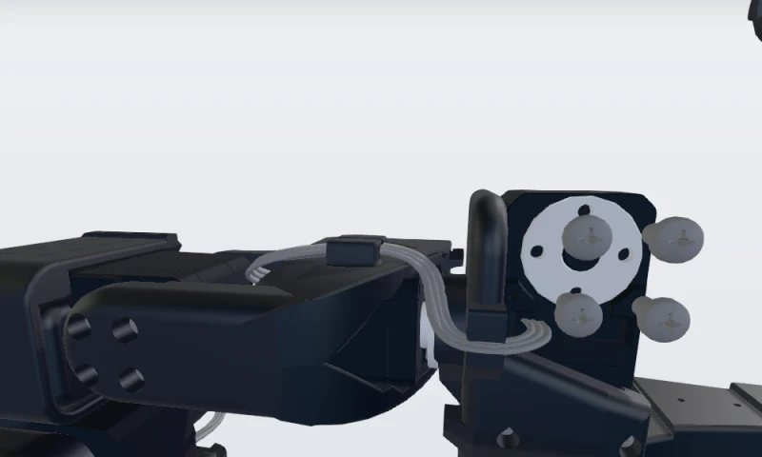
7 | Install the moving jaw  Place the moving jaw back on the new servo’s horns, facing the same way as before. | Screw holes lined up with the horns on both sides. | 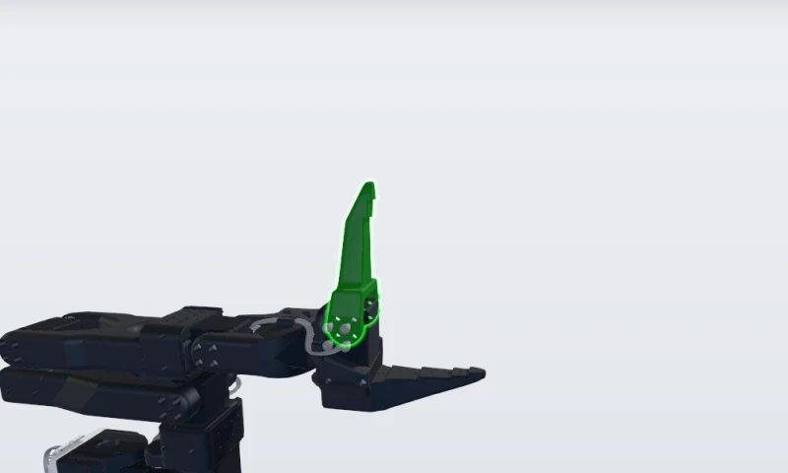
8 | Refit the first set of jaw screws  Refit the four M3 × 6 mm screws on this side. | Leave them slightly loose until all eight are in. | 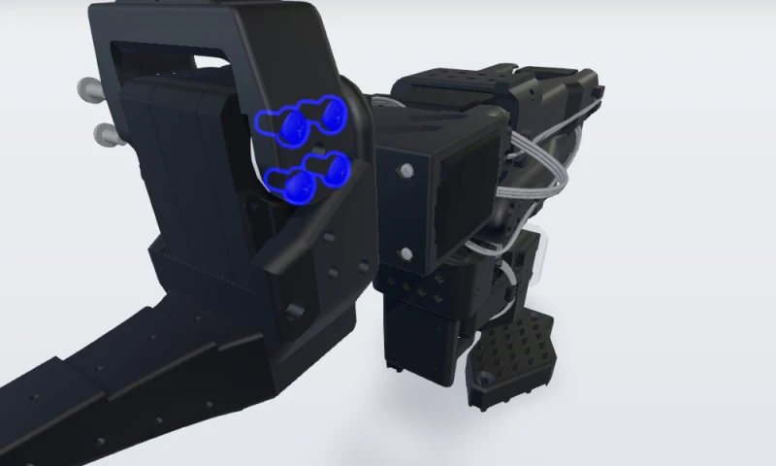
9 | Refit the second set and recalibrate  Refit the four M3 × 6 mm screws on the other side, then tighten all eight evenly. Reconnect power and USB and run lerobot-calibrate with the same arm name as before: every joint to the middle of its range, Enter, then each joint through its full range. | A new servo has no calibration. | 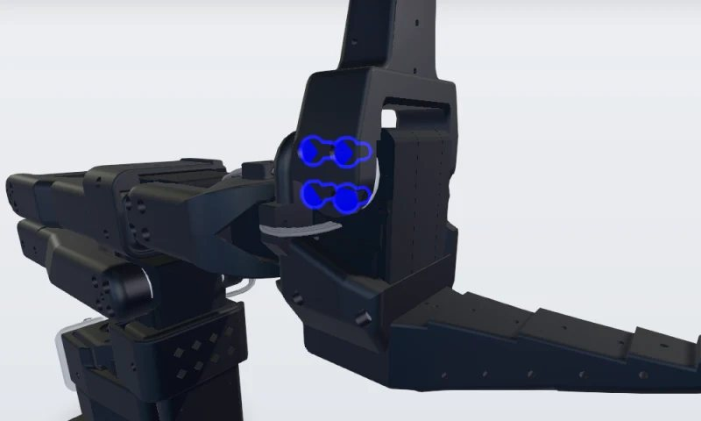

Check your understanding
Question | Answer
What ID does a new servo have, and which one does LeRobot expect for the gripper? | A new servo is set to ID 1; the gripper must be ID 6.
Why recalibrate after the replacement? | A new servo has no calibration.

Practical exercise
Replace the gripper servo of a training arm, from making it safe to recalibrating it, with this manual open.
Criterion | Done | Not yet | Trainer’s note
Power and USB disconnected before the first screw | ☐ | ☐
Same servo type fitted, output shaft on the moving-jaw side | ☐ | ☐
“'gripper' motor id set to 6” shown | ☐ | ☐
Arm recalibrated; jaw opens and closes freely | ☐ | ☐

Sign-off
 | Trainee | Trainer
Name
Signature
Date

Training record
One line per trainee and revision. Train again when the procedure changes revision.
Trainee | Date | Manual rev. | Result | Trainer | Refresher due
 |  |  | ☐ Competent ☐ Not yet
 |  |  | ☐ Competent ☐ Not yet
 |  |  | ☐ Competent ☐ Not yet
 |  |  | ☐ Competent ☐ Not yet
 |  |  | ☐ Competent ☐ Not yet

Glossary
Term | Definition
LeRobot | Hugging Face’s open-source robotics library, used to set up and calibrate the arm.
STS3215 | Feetech serial bus servo used in every joint of the SO-101.
Motor ID | Address of a servo on the bus. The gripper is ID 6.
Calibration | Recording each joint’s middle and range so the software moves the arm correctly.

Revision history
Rev. | Date | Description of the change | Author
A | 2026-11-04 | First issue (example) | TwinWorks

