WORK INSTRUCTION

Replace the gripper servo (motor 6), SO-101 follower arm
Product / part no. | SO-101 follower arm | Operation no. | 40 | Station / cell | Robotics lab bench
Takt time | — | Standard time | 20 min | Effective date | 2026-11-04
Prepared by | TwinWorks | Approved by | — | WI no. · Rev. | WI-EX-101 · A

Filled-in example from the public TwinWorks procedure “Replacing servomotor 6” for the open-source SO-101 arm; images from its 3D steps. Illustrative: check it against the LeRobot documentation before use.
Required PPE  Tick what applies |   ☐ Safety glasses |   ☐ Gloves |   ☐ Hearing protection |   ☐ Safety shoes |   ☐ Hard hat |   ☐ Mask / respirator | Other:  None beyond the lab rules. Power off before you start.

Tools and equipment | Parts and materials
• #1 Phillips screwdriver  • Computer with LeRobot installed | • 1 × Feetech STS3215 servo, 1/345 gearing (C001), same voltage as the arm  • 8 × M3 × 6 mm and 4 × M2 × 6 mm screws (reused)

Step | Image | What to do | Key points | ⚠ Safety | ✓ Quality
1 | 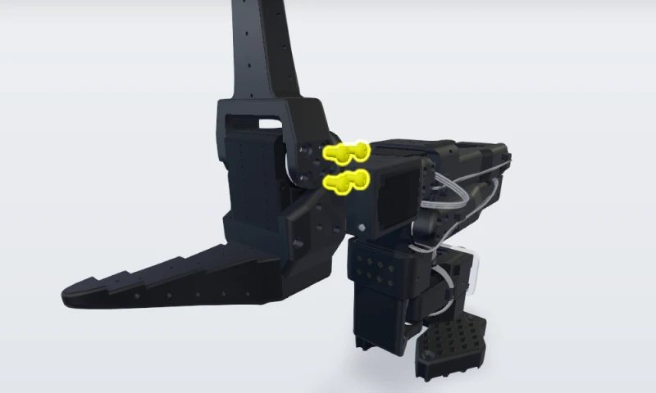 | Remove the first set of jaw screws  Disconnect the arm’s power supply and USB cable first. Then remove the four M3 × 6 mm screws that hold the moving jaw to the servo horn on this side. | #1 Phillips screwdriver. Keep the screws for reassembly. | Power and USB disconnected
2 | 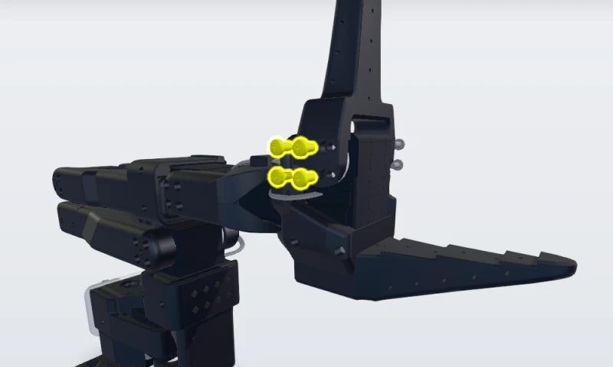 | Remove the second set of jaw screws  Remove the four M3 × 6 mm screws on the other side of the moving jaw. | Support the jaw as the last screw comes out.
3 | 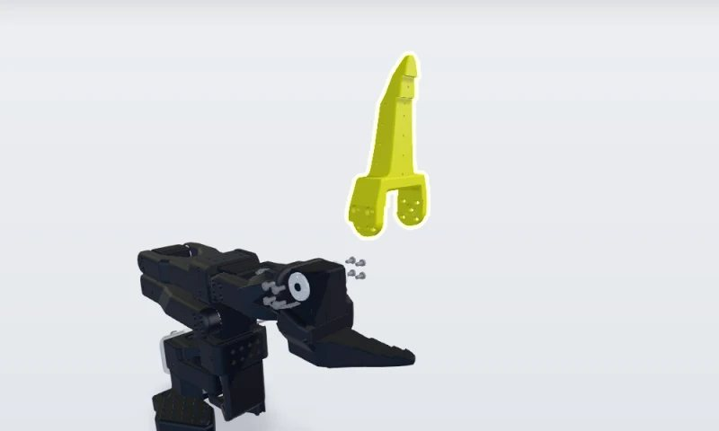 | Remove the moving jaw  Lift the moving jaw off the servo horns and set it aside with its eight screws. | Note which way it faces, to refit it the same way. |  | Jaw orientation noted
4 | 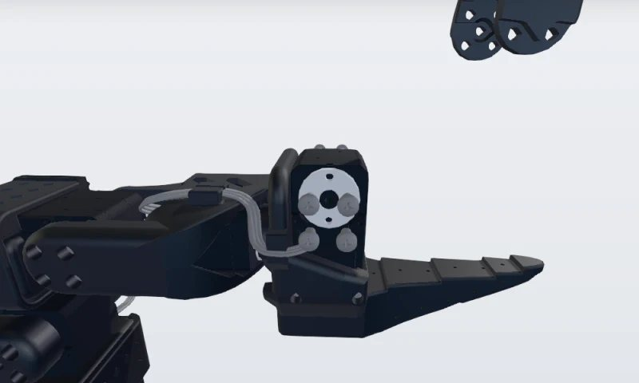 | Unplug servomotor 6  Unplug the 3-pin cable from servomotor 6. It is the last servo in the chain, so it has only one cable, coming from servomotor 5. | Pull the connector, not the wires.
5 | 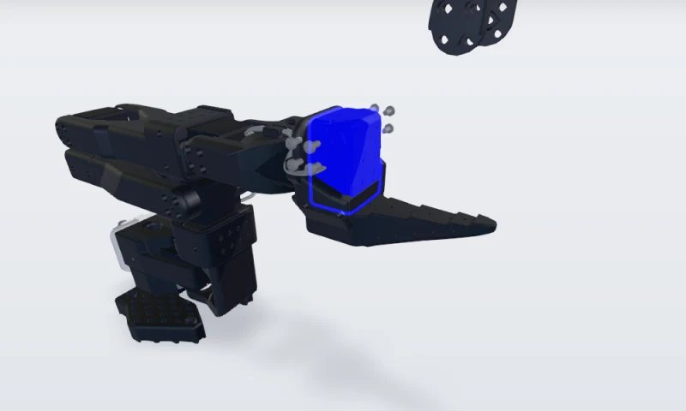 | Replace the servomotor  Remove the four M2 × 6 mm screws (two on each side) that hold servomotor 6 in the lower jaw and slide the old servo out. Fit both horns on the new STS3215 (1/345 gearing), securing the top horn with an M3 × 6 mm screw. Slide it in and refit the four M2 × 6 mm screws. | Output shaft on the moving-jaw side. The bottom horn needs no screw. |  | Same servo type: STS3215, 1/345
6 | 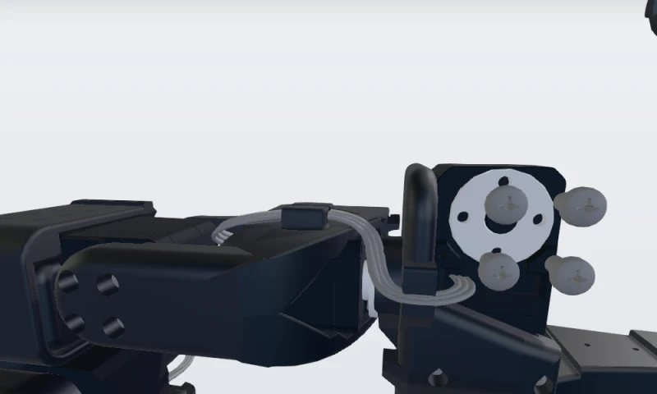 | Give the new servo ID 6, then plug it in  Connect the driver board to the new servo alone, power it and run lerobot-setup-motors --robot.type=so101_follower. Press Enter at the gripper prompt, wait for “'gripper' motor id set to 6”, then stop the script. Power off, reconnect the board to servomotor 1 and plug the cable from servomotor 5 into the new servo. | A new servo comes set to ID 1. | Power off before you reconnect | “motor id set to 6” shown
7 | 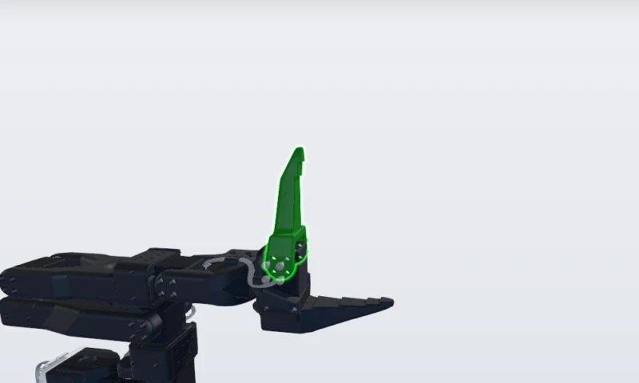 | Install the moving jaw  Place the moving jaw back on the new servo’s horns, facing the same way as before. | Screw holes lined up with the horns on both sides.
8 | 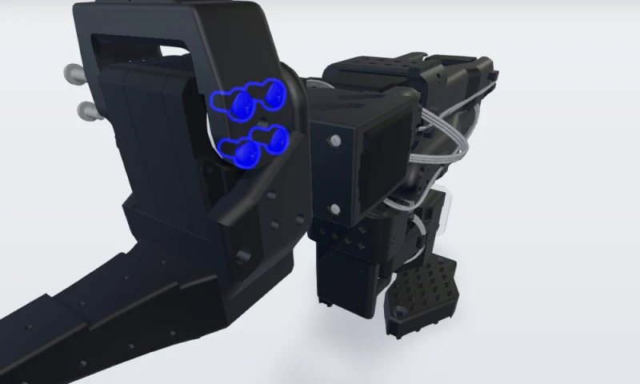 | Refit the first set of jaw screws  Refit the four M3 × 6 mm screws on this side. | Leave them slightly loose until all eight are in.
9 | 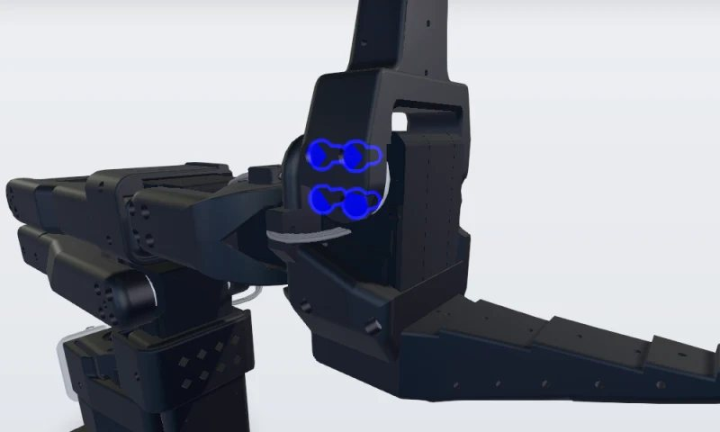 | Refit the second set and recalibrate  Refit the four M3 × 6 mm screws on the other side, then tighten all eight evenly. Reconnect power and USB and run lerobot-calibrate with the same arm name as before: every joint to the middle of its range, Enter, then each joint through its full range. | A new servo has no calibration. | Keep fingers clear of the jaw when powered | Jaw opens and closes freely

Sign-off
 | Prepared by | Checked by | Approved by
Name
Signature
Date

Operator training record
Operator | Trained by | Date | Signature

Revision history
Rev. | Date | Change | By | Approved
A | 2026-11-04 | First issue (example)

